Hussain Ather

Lab Partner: Michael Peng

Oct 19, 2013

Prof. de Souza and Iyengar

Lab TA: Daniel Ashley

Analysis of the spectrometric properties of CdSe as a Quantum Dot

**Intro:**

The quantum mechanical “particle in a box” diagram describes the fundamentals of subatomic behavior. Confinement of a single particle in a box with walls of infinite potential introduces quantization in a manner that is dependent on the length of the box. This demonstrates the behavior that lays the foundation for Quantum Dots: nanometer-scaled particles that exhibit quantum mechanical behavior. The electrons in the quantum dots can be modeled as particles “confined in a ‘box’ with infinite walls”1

***Fig. 1****: The “particle-in-a-box” diagram of a*

*Mg crystal shows the lack of a band-gap between*

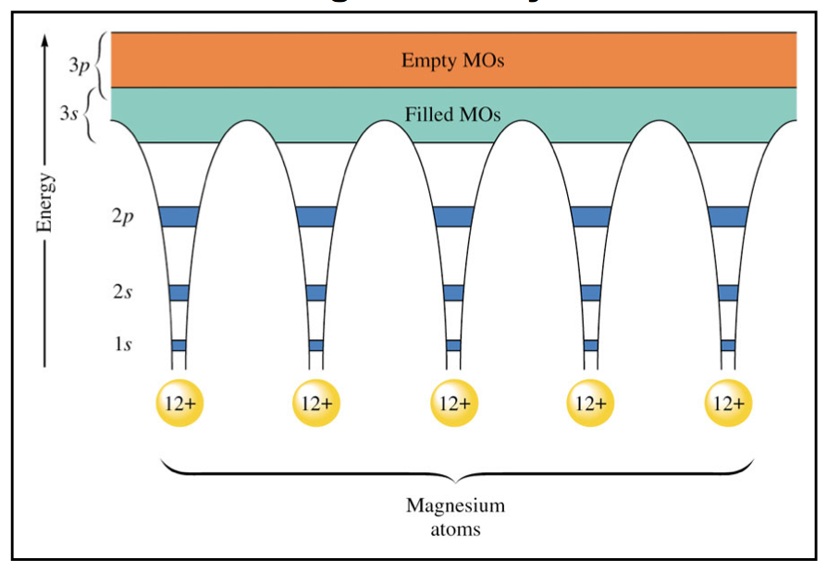*the empty and filled 3s and 3p molecular orbitals. 1* According to the “particle-in-a-box” diagram, spacing between energy levels decreases as the length of the box increases, and, if we assume that the same holds true for QD (quantum dot models), an increased length of quantum dot particles would be expected to have a lower absorbance energy, which would be observed in their absorbance spectra. For quantum-dot properties to be observed, the gap must be small enough for electrons to pass between the two regions, but large enough that electrons will still be able to be excited to jump between the regions. Through synthesis of CdO with Se solution, CdSe quantum dots will be produced to show the quantum dot behavior.

**Beginnings Questions:**

What happens to the color of the samples over time?

How do the colors change when viewed under a UV light?

How does the structure of CdSe make it exhibit “quantum-dot” properties?

**Procedure:**

**Week 1:**

13 mg of CdO was weighed and added to a 25 mL round-bottom flask covered by parafilm. It was clamped to a ring stand. 6 mL of oleic acid was measured with a graduated pipet, and 10 mL octadecene was measured with a graduated cylinder. These two were added to the flask. The thermowell was half-filled with sand and placed on a ring stand with the setting at 5. A thermometer was clamped to be secured to take the temperature of the solution in the flask. When the solution reached about 180°, it was mixed with a 9” pipet to fully dissolve the CdO. 1.0 mL selenium solution was transferred from the stock solution to a graduated cylinder using a graduated pipet. When the temperature reached 225°, a timer was started and the selenium solution was added from the graduated cylinder to the flask. Approximately 1.0 mL of the flask solution was extracted using a 9” pipet and placed into an empty test tube at each time interval. The time intervals for the lab handout were not followed due to time restraints. Observations of the color were made, but not with UV light due to time restraints. The test tube samples were kept on a test tube rack and stored in the lab until next week.

**Week 2:**

A plastic cuvette was rinsed with octadecene, and another was filled with octadecene. The cuvette filled with octadecene was placed into the UV-VIS spectrophotometer, and the spectrophotometer was “zeroed”to provide a relative sample for the test tube samples to be compared to. Each sample was moved the cuvette that had been rinsed in order to scan the absorbance spectra using the UV-VIS spectrophotometer. Each sample was also diluted with octadecene to raise the volume up to a height that could be detected by the spectrophotometer. Between each trial, the cuvette was rinsed with octadecene, and the UV-VIS spectrometer was zeroed with the octadecene cuvette. For each sample, absorbance spectra was graphed and saved onto the computer from 425-625nm.

**Results:**

**Fig. 2**: Extraction time, color, wavelength, energy, and radius of each sample. The table had to be split with the right-half below the left-half due to formatting. Each sample was extracted, one after the other, due to time constraints, rather than at the time intervals given in the original lab report. The data shown is a “high-resolution” image of a small section of the CdSe quantum dot absorbance spectra because it is a large number of trials over a small range of times. The calculations for wavelength and energy are shown below.

|  |  |  |
| --- | --- | --- |
| **Sample #** | **Time extracted (s)** | **Color** |
| 1 | 7 | Yellow |
| 2 | 15 | Orange |
| 3 | 26 | Orange |
| 4 | 31 | Orange |
| 5 | 37 | Orange |
| 6 | 45 | Orange |
| 7 | 55 | Orange |
| 8 | 64 | Orange |
| 9 | 74 | Orange |
| 10 | 81 | Orange-Red |
| **Wavelength of band-gap cut-off (nm)** | **Energy of corresponding wavelength (J)** | **Radius (m)** |
| 558.170 | 3.56128×10-19 | 3.60892x10-9 |
| 598.889 | 3.31915×10-19 | 3.37301 x10-9 |
| 581.882 | 3.41616 x 10-19 | 3.37979 x10-9 |
| 584.667 | 3.39988x10-19 | 3.37163 x10-9 |
| 582.963 | 3.40980×10-19 | 3.76544 x10-9 |
| 590.700 | 3.36287×10-19 | 3.54751 x10-9 |
| 611.848 | 3.24885 x10-19 | 3.31364 x10-9 |
| 596.483 | 3.33253 x 10-19 | 3.42388 x10-9 |
| 588.714 | 3.37651x10-19 | 3.60724 x10-9 |
| 605.939 | 3.28053x10-19 | 3.23715 x10-9 |

**Fig 3**: Absorbance vs. Wavelength (nm) of CdSe samples of various times (s) of extraction: The higher the extraction time, the steeper the slope of Absorbance/wavelength appeared. Also, the color of the line on the graph corresponds to the color of the sample (though it will print in black and white).

**Figures 4-5:** Absorbance vs. Wavelength (nm) of CdSe samples of individual samples 1 and 10.

For sample 1, the calculation of the energy of the minimum energy band-gap cutoff wavelength is given. By the equation y = -0.0006x + 0.3349, the x-intercept of the “linear” portion of the graph is determined to be 558.17 nm. This corresponds to 3.5589×10-19 J (calculation below). The calculations for the rest of the samples are shown below as well.

E =hν 🡪 c= λν 🡪 E =hc/λ

Sample 1: $E=\frac{6.626x{10}^{-34} Js)(3.00x{10}^{8}m/s)}{(558.17nm)({10}^{-9}m)/nm}= 3.56128×{10}^{-19} J$

**Fig. 8:** (Picture sources)78 Calculating the radius of the CdSe quantum dot given the Egbulk (band-gap bulk CdSe at room temperature) and the experimentally-determined Eg* (band-gap nanoparticle energy). The bulk band-energy cut-off for CdSe (Egbulk) has been determined, by other sources, to be 1.74 eV (2.788×10-19 J)6  and 2.45eV (3.88x10-19J)8. For this calculation 2.45eV (3.88x10-19J) will be used. From this the value a can be calculated, and, using the quadratic formula, the radius can be calculated.

Sample 1: a = -3.211x10-20  J 🡪 r=4.8094x10-9 m

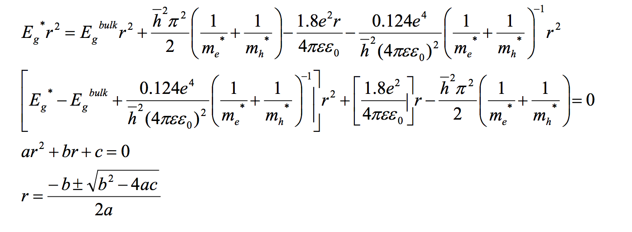

(Equation Images)8

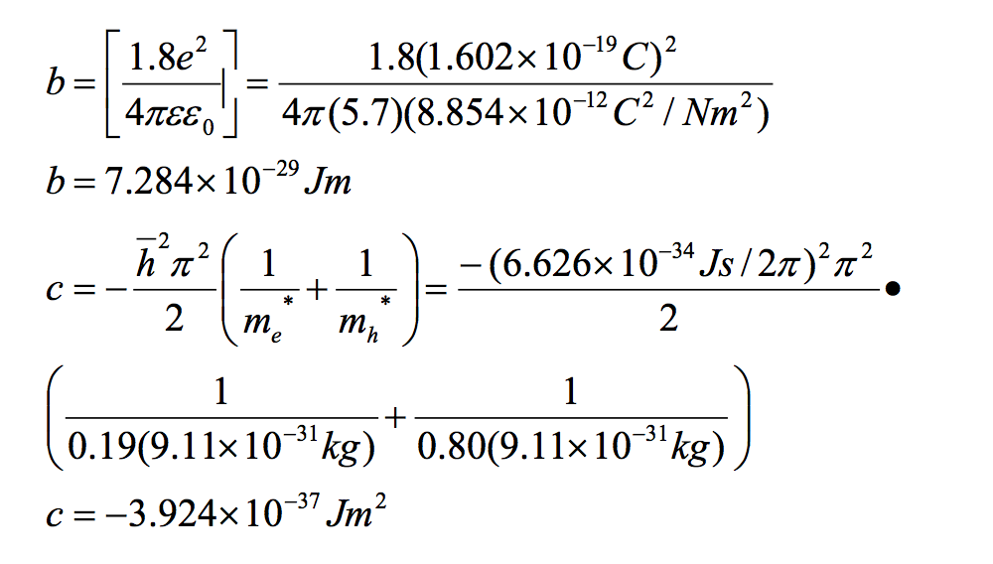

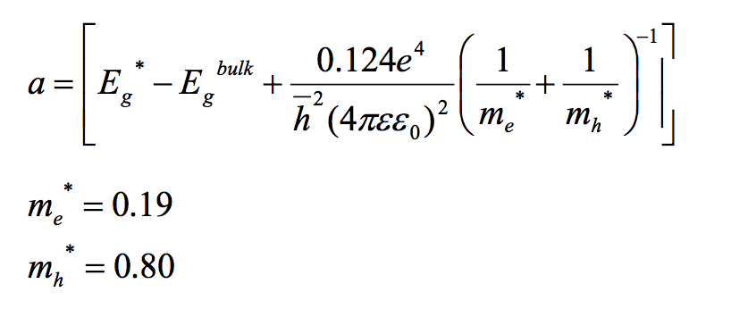

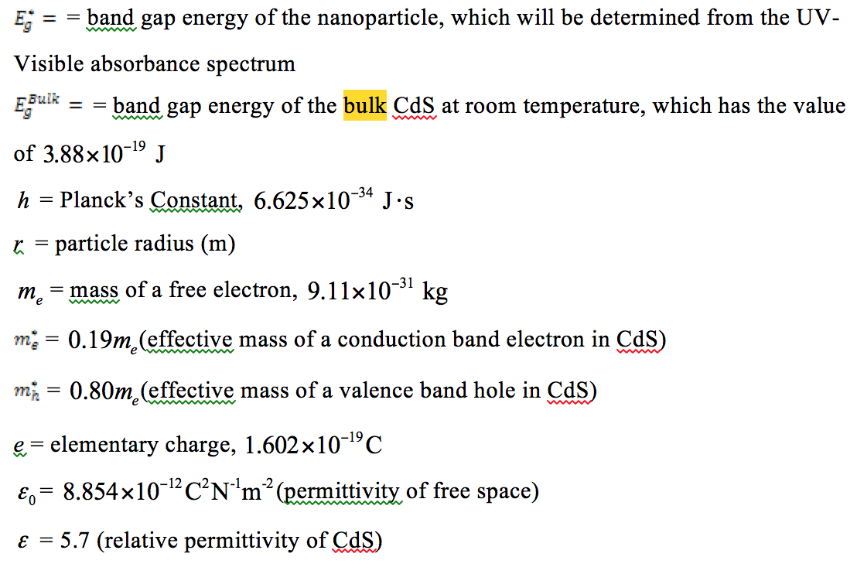

**Discussion:**

The experiment was designed to figure out the minimum band-gap size at which electrons could excite their energy levels. In order for a semiconductor to conduct, the electrons must have enough energy to cross the band-gap, which is at a size that is not too large to be an insulator, but not too small to be a conductor. These band-gaps decrease as size of the nanocrystal increases because there is greater overlap in the molecular orbitals in the “particle-in-a-box” model of quantum dots. Also, as the amount of heat put into the system increases, the size of the nanoparticles increases by “swelling.” This is why samples that were extracted later have larger nanoparticle sizes. As the time of the sample extracted increases, the wavelength of the emitted light is longer (for most of the obtained samples), and the observed color shifts from yellow to red. The band-gap energy decreases with increasing wavelength. It would require less energy for electrons to move between the filled and unfilled orbitals. This corresponds to lower band-gap cut-off energies, which is consistent with the “particle-in-a-box” model”. Thus, quantum dots extracted later have larger lengths.

For the particle-in-a-box system:

$$E=\frac{n^{2}h^{2}}{8mL^{2}}$$

$$∆E=\frac{n^{2}h^{2}}{8mL^{2}}\left(final\right)-\frac{n^{2}h^{2}}{8mL^{2}}\left(initial\right)=\frac{h^{2}}{8m}(\frac{{n_{f}}^{2}}{{L_{f}}^{2}}-\frac{{n_{i}}^{2}}{{L_{i}}^{2}})$$

Since n and L are the only quantities that change, the change in energy is only dependent upon the n and L. The change in energy is indirectly proportional to L2. This is similar to the data obtained for the quantum dots. Quantum dots extracted later have higher radii of the nanocrystal according to the experimental data. This shows that quantum dots do behave like the “particle-in-a-box” model in this sense.

Oleic acid was used to slow the growth rate of the nanocrystals so that they could be collected at the nanoscale level.4 They also keep the electron-hole pairs in their proper places by capping the surfaces of the nanocrystals themselves. It prevents “oxidation and aggregation”5 by isolating the particles. The bits that make up quantum dots at a nanometer scale would grow over time in response to the heat by “swelling.” The particle size grows rapidly at the beginning rather than later in the experiment because there is less mass to be heated at that time, meaning the temperature of the particles can rise more rapidly with a given amount of heat added to the system.

After calculating the radii for each quantum dot sample, as the wavelength of the band-gap cutoff increases (and that corresponding energy decreases), the radius of the nanoparticle decreases. This is consistent with the particle-in-a-box comparison that demonstrates that, as the length of the box increases, the energy gaps become closer to one another, thus decreasing the energy band-gap cutoff.

The experimental samples were not sufficiently heated to 225°C, only to about 210°C, meaning that the quantum dot samples might not have been supersatured. The atoms might not have been rearranged enough to increase ductility and to allow nanocrystals to successfully grow. Since the extraction times were so close to one another, it was difficult to precisely record the exact time of each extraction. This contributes to error that the times are not fully precise. Quantum dots have applications in real-world systems such as LED lights and biomedical sensors. Their photoluminescent properties allow specific wavelengths of light to be emitted, and, due to their nanoscale size and long lifespan, they can be used in biomedical imaging for cancerous cells.2 This experiment could be improved with a more efficient way to heat the flask while still keeping the temperature under control in order to reach the given temperature faster. Extracting more than 1.0 mL of the CdSe solution would improve the results, since they wouldn’t have to be diluted before adding to the cuvette in order to be analyzed by the spectrophotometer.

**Conclusion:**

The experiment successfully showed the relationship between the absorbance spectra of quantum dots and the corresponding energy of its electrons. Over time, the color of the samples shifted from yellow to orange-red, moving form lower to higher wavelengths. Due to time constraints, the samples were not viewed under UV light. CdSe molecules have molecular orbitals that overlap in such a way that creates a band-gap small enough for some electrons to have enough energy to move between the empty and filled orbitals. This allows it to function as a semiconductor, exhibiting “quantum-dot” properties.

References

1. Iyengar, Srinivasan. *Lab Lecture.*

2. Trivedi, Evan R., and Shelby L. Hatch. "Synthesis and Size Dependent Properties of CdSe Quantum Dots." *NanoHub*. NCN, 2009. Web.

3. Lee, Howard. "Mighty Small Dots." *Lawrence Livermore National Laboratory*. Lawrence Livermore National Security, n.d. Web.

4. Silk, Ely. "The Process of Making Core Nanocrystals." *Views from Science*. N.p., 2010. Web.

5. Brus, Louis. "Chemistry and Physics of Semiconductor Nanocrystals." *Columbia University*. Columbia University, 2007. Web.

6. Dipesh, Neupane. "Structural and Optical Investigation of CdSe." *Kathmandu University Journal of Science, Engineering, and Technology*. Kathmandu University, Department of Physics, Banaras Hindu University. 2012. Web.

7. Q. Xie, F. McCourt, *Nanotechnology Engineering NE 320L Lab Manual*, University of Waterloo, Waterloo, pp 23-30 (2008)

8. "Characterization of Materials." *DEPARTMENT OF CHEMISTRY: Indiana University*. University of Waterloo. Nanotechnology Engineering, n.d. Web.